# Scenario 2: Create a new Project

## Scenario Description

* All functionality relating to creating a new project

## Version Control

|  |  |  |  |
| --- | --- | --- | --- |
| Version # | Date | Author | Description |
| 1.0 | 10/08/2019 | Brodie Osborn | Initial Version |

## Test Scripts

The following scripts will cover this scenario:

* 1.1 Successfully create new Project

## Use Case

* Create new Project

## Test Components/Requirements

This test scenario covers the following high-level test requirements (see scripts below for specific requirements covered by each test script):

* Ensure that a new project can be created with basic initial conditions
* Ensure that the new project is stored within the system properly

## User Groups

* Project ManagerScript 1.1: Successfully create new project

### Script Description

* A Project Manager is able to create a new project with basic initial conditions: in this case a name and no specific skill requirements (these are covered by the appropriate other use case).

### Testing Requirements

This test script covers the following specific testing requirements:

* Ensure that a new project can be created with basic initial conditions
* Ensure that the new project is stored within the system properly

### Setup

* Test Project 1 must not exist within the system

### Teardown

* None

### Script Steps

| **Step #** | **Test Action** | **Expected Results** | **Pass/ Fail** |
| --- | --- | --- | --- |
| 1 | Click “Manage Projects” Button | Open Projects Page | PASS  (see screenshot 1) |
| 2 | Click “Add Project” Button | Open New Project window | PASS  (see screenshot 2) |
| 3 | Enter the name “Test Project 1” into the Name field |  | PASS |
| 4 | Click the “Create Project” button | Test Project 1 is saved into the projects list  User is returned to the Projects Page  Test Project 1 is now visible in the projects list | PASS  (see screenshot 3) |

### Test Execution

|  |  |  |  |  |
| --- | --- | --- | --- | --- |
| Date/Time | Tester | Test ID | Test Phase | Status |
| 08/09/2019 | Brodie Osborn | #1 | IOCM | Testing Complete |

## Screenshots

1.

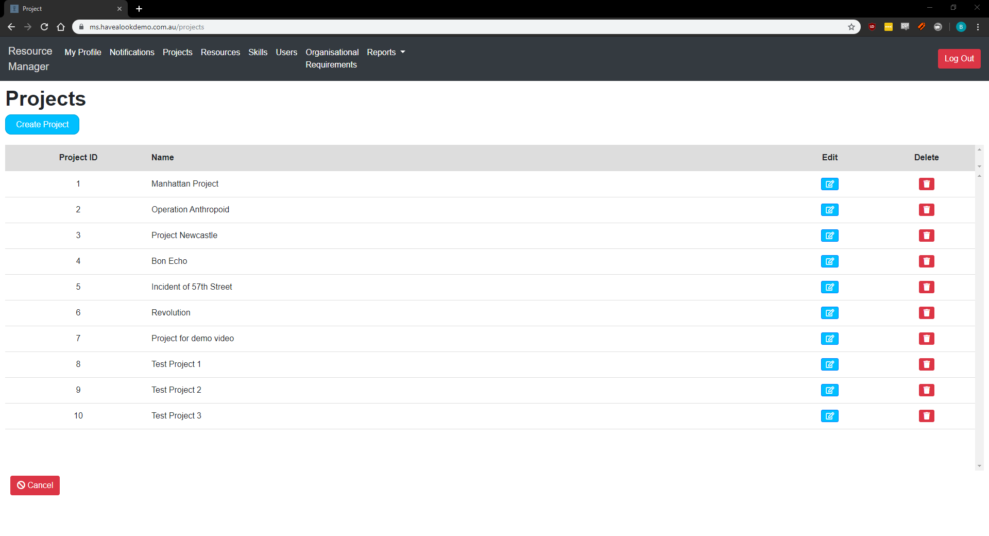

2.

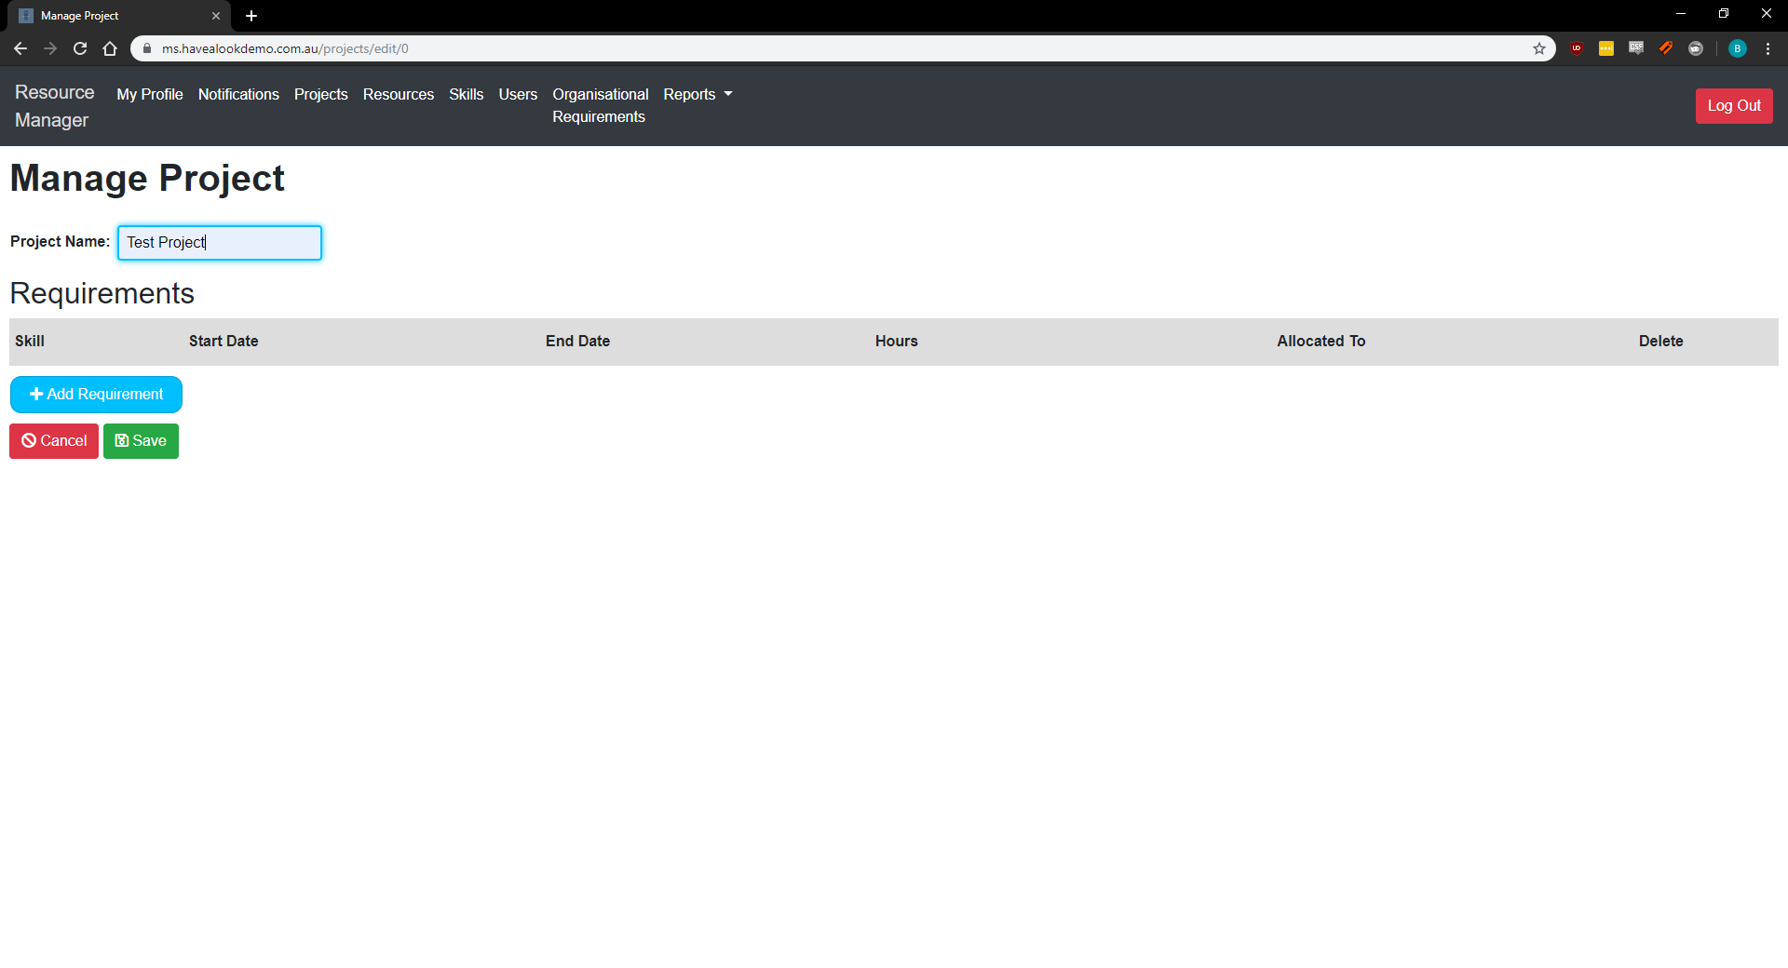

3.

